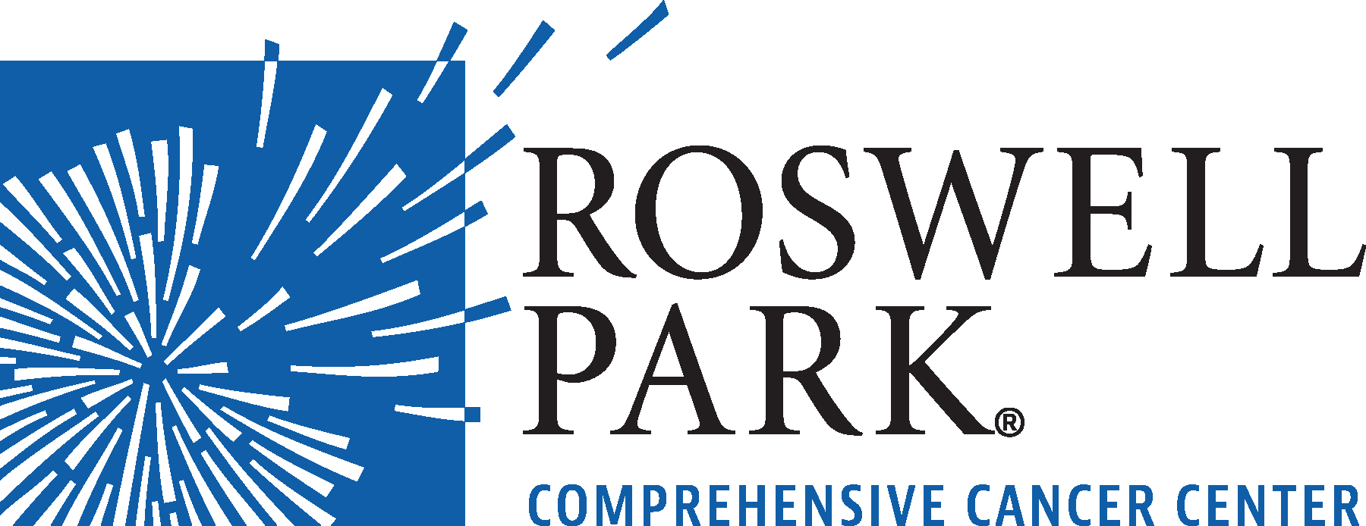 | FOR IMMEDIATE RELEASE  September 11, 2024  Contact: Annie Deck-Miller, Roswell Park  716-845-8593; annie.deck-miller@roswellpark.org

– MEETING NOTICE –

WHAT: Board of Directors Meeting
Roswell Park Comprehensive Cancer Center
WHEN Thursday, September 26, 2024
Noon

WHERE Roswell Park Comprehensive Cancer Center
The Community Outreach & Engagement Center
907 Michigan Street
Buffalo, NY 14263

Click here to join meeting: https://www.roswellpark.org/boardofdirectorsmeeting

From the world’s first chemotherapy research to the PSA prostate cancer biomarker, Roswell Park Comprehensive Cancer Center generates innovations that shape how cancer is detected, treated and prevented worldwide. Driven to eliminate cancer’s grip on humanity, the Roswell Park team of 4,000 makes compassionate, patient-centered cancer care and services accessible across New York State and beyond. Founded in 1898, Roswell Park was among the first three cancer centers nationwide to become a National Cancer Institute-designated comprehensive cancer center and is the only one to hold this designation in Upstate New York. To learn more about Roswell Park Comprehensive Cancer Center and the Roswell Park Care Network, visit www.roswellpark.org, call 1-800-ROSWELL (1-800-767-9355) or email ASKRoswell@RoswellPark.org.

